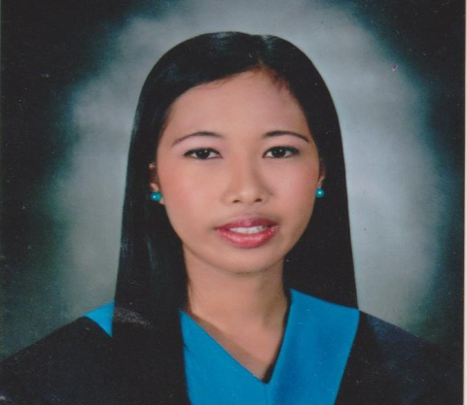
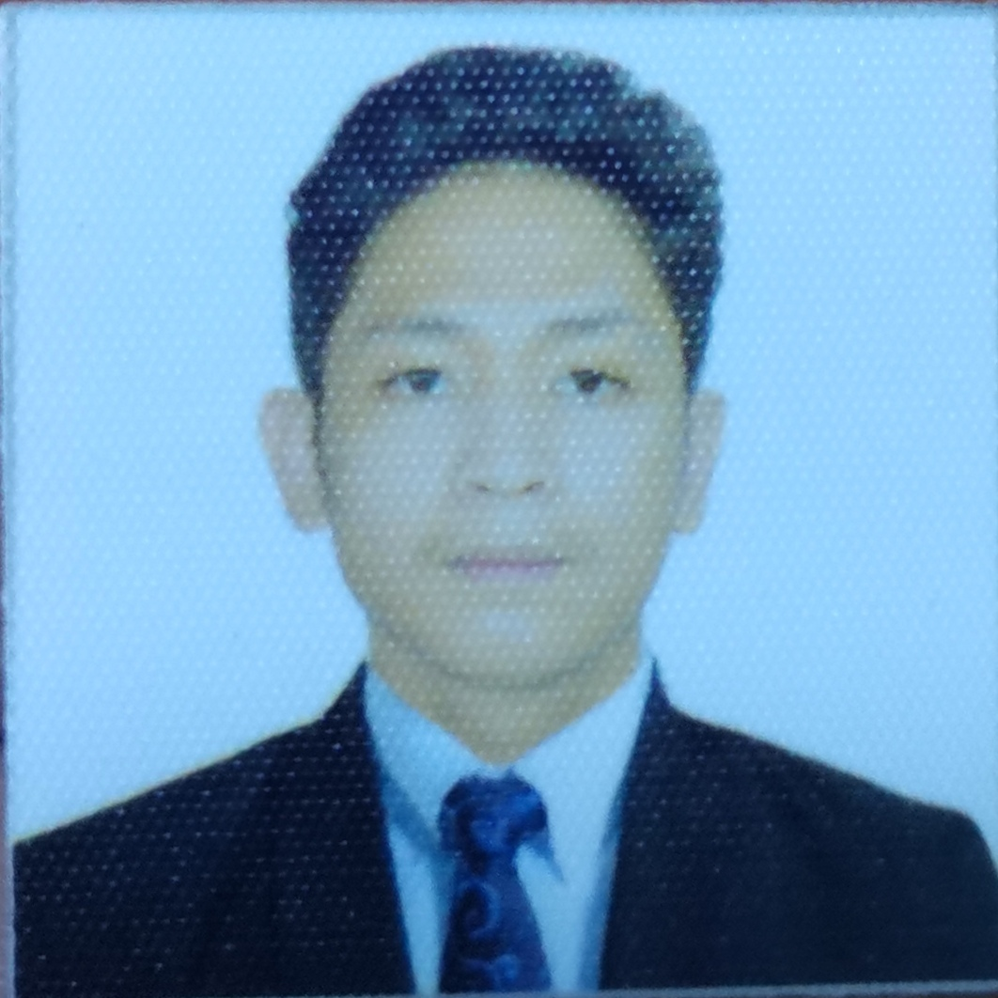

PERSONAL DATA

AGE:  DATE OF BIRTH:  PLACE OF BIRTH:  GENDER:  HEIGHT:  WEIGHT:  NATIONALITY:  CIVIL STATUS:  RELIGION:  NAME OF FATHER:  NAME OF MOTHER:
  24
  Feb. 21,1998
  Sta.Rosa Laguna
  Male
  5’ 7”
  59 kg.
  Filipino
  Single
  Roman Catholic
  Domingo Cantos Fernandez
  Emelie Sayson Fernandez

EDUCATIONAL BACKGROUND

TERTIARY:
B.S in Computer Engineering
STI COLLEGE
Sta.Rosa Laguna
Batch 2015 - 2020

SECONDARY:
Blessed Christian School
Balibago, Sta.Rosa Laguna
Batch 2012 - 2015

PRIMARY:
Balibago Elementary School
Balibago, Sta.Rosa Laguna
Batch 2007 - 2012

SKILLS

- Microsoft Office Specialist (Adept in various Computer Applications)
- Analytical skill
- Interpersonal skills
- Highly – organized, efficient and can work under pressure.
- Problem-solving
- Decision-making
- Editing Skills ( Pictures and Video's)
- Critical thinking
- Adaptability

6

Harley Kier S. Fernandez
#350 Amar Village, Brgy.Balibago Sta. Rosa, Laguna 4026
harleykierfernandez21@gmail.com
0991-468-7596
0955-431-8567

CAREER OBJECTIVES

To pursue a career, that will further enhance my capabilities and competence, while providing the society’s needs at a given time.

SEMINARS ATTENDED

- Cpeyesta 2016: ICpep.se Region IV-A Second General Assembly – October 1,2016
- 3rd ICpep.se General Assembly – September 29,2017
- Financial Education September 21, 2018
- COESEFT 1ST Seminar - August 26, 2018

WORK EXPERIENCE
- COMPANY:  - ADRESS:  - NATURE OF BUSINESS:  - TENURE:  - POSITION: | UNIVERSAL ROBINA CORP. (URC)  50 KM San Cristobal, Calamba City, Laguna  Snacks  September 16,2020 up to present  Machine Operator - Mixer/Extruder (PROCESS)
DUTIES AND RESPONSIBILITIES

- RESPONSIBLE TO PREPARE THE EQUIPMENTS OF MACHINES BEFORE THE OPERATION.
- MONITOR THE MACHINE'S DURING THE OPERATION.
- RESPONSIBLE TO WRITE A PMS REPORT DURING THE OPERATION.
- RESPONSIBLE IN TROUBLE SHOOTING A MACHINE DURING THE OPERATION.
- RESPONSIBLE OF CLEANING THE MACHINE'S.
- CONDUCT A BASIC EQUIPMENT CARE (BEC) AFTER THE OPERATION.
- RESPONSIBLE FOR TEACHING AND ASSIST THE OJT.
- REPAIR ADJUSTMENT OF THE MACHINE'S.
- RESPONSIBLE FOR THE START UP AND SHUTDOWN THE MACHINE'S.
- FOLLOW OPERATING STANDARD PROCEDURES WITH REGARD TO SAFETY.
- SUPPORT AND ASSIST THE TECHNICIAN OR MAITENANCE WORKS OTHER THAN BEING OPERATOR, IF MY SERVICE REQUIRED.

BASIC RELATIONSHIP

- Report directly to Supervisor
- Coordinate with co-operator for any pending or unfinish job.

REFERENCES

Engr.Allen Vincent Del Moro
Supervisor
Mcalvinxxi@gmail.com
Banlic,Cabuyao,Philipinnes

