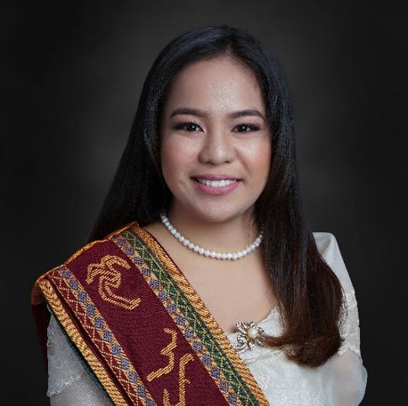
LAURICE T. SAN JUAN
OBJECTIVES
Food Technologist
A graduate of BS Food Technology with a 2-year job experience in Quality Control, on-the-job training experience in Research & Development, and exposure to food processing and food science research during undergrad.
To establish a career in the food industry and be able to harness the best of my knowledge and employ my skills and potential in the many branches of food technology such as in Research & Development, Food Manufacturing, Quality Assurance, Quality Control, and Food Sales & Marketing.
To enhance my positive attitude towards work, good human relationship, competency in technical skills that pertain to my fields of study and experience, and openness to keep on learning for the benefit of my employer, my community, and myself.
CONTACT INFO:
+63 936-680-1151
lauricetsanjuan@gmail.com
080 N. Basco Street,
Brgy. Balibago, Talim Island,
Cardona, Rizal, 1950

PERSONAL INFO:
Birthday: Aug 07, 1996
Age: 26
Sex: Female
Height: 5’4”
Weight: 65 kilos
Civil Status: Single
Nationality: Filipino
Religion: Catholic

REFERENCES:
Prof. Abigail S. Rustia
UP PFP/FIF Faculty-in-Charge
College of Home Economics,
UP Diliman
asrustia@up.edu.ph

Anthony S. Angeles
R&D Intern’s Supervisor
Fresh ‘n Famous Greenwich
anthony.angeles@greenwich.com.ph

Eloisa B. Espiritu
QC/QA Supervisor
Marigold Manufacturing Corp.
eloisaespiritu@gmail.com

EDUCATIONAL BACKGROUND
- University of Philippines, Diliman
  - Bachelor of Science in Food Technology
  - 2015 – 2019
- University of Philippines, Baguio
  - Bachelor of Science in Computer Science
  - 2013 – 2015
- Tuna-Balibago Nat’l High School
  - Valedictorian
  - 2009 – 2013

AREAS OF EXPERIENCE
- Marigold Manufacturing Corporation
- QC Process Inspector / QC Lab Analyst
- July 2020 – Present
- In-line monitoring and verification of process procedures and standard specifications.
- Creation, evaluation, and revision of procedures, work instructions, monitoring forms, standard guides, and process control documents based on coherence of production practices to standard procedures and effectiveness in the line process.
- Reporting, monitoring, communication, and disposition issuance on process deviations and non-conforming products.
- Assessment on manpower’s quality knowledge in terms of standard procedures and parameters.
- Involved in different company projects that addresses specific in-line problems through GSTD (Go, See, Think, Do) and DMAIC (Define, Measure, Analyze, Improve, Control) approaches.
- Leading the above mentioned projects from planning, defining the problem, gathering and stratifying, analyzing data, finding ways to improve and control the process problem, and presentation of the entire project to the stakeholders.

- Internship at Fresh ‘n Famous Greenwich
- JJACCIS, Shaw Boulevard, Pasig City
- June 2019 – September 2019
- Involved in the works of technology & food solutions, research & development, and sensory & technical services
- Project on dough

SEMINARS AND TRAININGS
- DMAIC – Define Measure Analyze Improve Control
- Halal
- HACCP SSOP
- Food Safety
- CCP/OPRP
- Document Control
- Food Fraud
- QC Lab Analyst
- RCA
- AX 100 Printer Training and Seminar May 18, 2021

KNOWLEDGE AND SKILLS
- Microsoft Office Proficient
  - MS Word, MS Excel, MS Powerpoint
- Good Written and Oral Communication Skills
- Good Listening and Comprehension Skills

PERSONAL QUALITIES
Being calm and determined under pressure are in my nature. I believe that I have also built my patience through various experiences in life. I consider myself sociable who can work and communicate with people from different levels of the organization but can also work independently. These qualities harden me and taught me how to be flexible, teachable, and adaptable. Sense of responsibility, resourcefulness, and hard work are my vital characters towards work which help me to multitask and work effectively and productively.

I hereby attest that the information above is true and correct to the best of my knowledge and belief.

Laurice T. San Juan
Signature

